M-estimators have been widely used in statistics to separate the outlying noise in the data. M-estimators are generalizations of the usual maximum likelihood estimates(MLE). MLE is a method to find the parameters of a statistical model in such a way that it becomes maximal likely to observe the given data set. This proposition already contains the greatest weakness of this method: the data generating process must be known in order to choose the correct model. If the model is chosen even slightly wrong, no parameter optimization can generate a meaningful result. Often, the correct model is not known or the data set contains outliers that make it impossible to estimate the correct parameters even if the underlying model might be correct. M-estimators are designed in such a way that they still produce meaningful results, even if the model assumption is not correct or the data contains outliers. [FUZZY]

Consider the linear model for the ith of n observation of a vector y:
y_{i}= α+β₁x_{i1}+β₂x_{i2}+β₃x_{i3}….. +β_{k}x_{ik}+µ_{i}= x’_{i}β+µ_{i}

If p.d.f of y is f, we can define ρ = −log f. Then the general M-Estimator minimizes the objective function
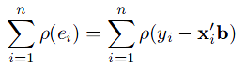 (A)
where the function ρ gives the contribution of each residual to the objective function. Residual is the difference between the i^{th} observation and its fitted value. ρ should have the following properties:
- ρ(e) ≥0
- ρ(0)=0
- ρ(e)= ρ(-e)
- ρ(e_{i}) ≥ρ(e_{i}’) for |e_{i}| ≥ |e_{i}’|
Therefore ρ is a symmetric, positive-definite function with a unique minimum at zero, and is chosen to be less increasing than square. Instead of solving directly this problem, we can implement it as an iterated reweighted least-squares one. Let p = [p₁; : : : ; p_{m}]^{T} be the parameter vector to be estimated. The M-estimator of p based on the function ρ (r_{i}) is the vector p which is the solution of the following m equations: 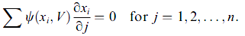
where the derivative ω (x) = dρ(x)/dx is called the influence function. The influence function ω(x) measures the effect of data on the value of the parameter estimate.

When an estimator is robust, it may be inferred that the influence of any single observation (datum) is insufficient to yield any significant offset. If there are no outliers and the data is only corrupted by Gaussian noise, we may expect the estimator to have an approximately normal distribution.

M-Estimators were developed due to a flaw in the Least Squares Method. Least-squares estimates can behave badly when the error distribution is not normal, particularly when the errors are heavy-tailed. Even if the true distribution deviates slightly from the assumed normal one, the sample mean then may have a catastrophically bad performance. At the core of the method of least squares lies the idea to minimize the sum of the squared "errors," that is, to adjust the unknown parameters such that the sum of the squares of the differences between observed and computed values is minimized. Since it can be easily influenced, another approach, termed robust regression can be used, which employs a fitting criterion that is not as vulnerable as least squares to unusual data, which tries to minimize ∑_{i} (x_{i} - T) ². The most common general method of robust regression is M-estimation, introduced by Huber (1964).Huber’s paper contained a new approach toward a theory of robust estimation; it treated in detail the asymptotic theory of estimating a location parameter for contaminated normal distributions, and provided estimators--intermediaries between sample mean and sample median--that are asymptotically more robust. Let x₁, …., x_{n} be independent random variables with common distribution function F(t - x_{i}). The problem was to estimate the location parameter x_{i}, but with the complication that the prototype distribution F(t) is only approximately known.
It concentrated its attention to estimators that can be defined by a minimum principle of the form (for a location parameter). This class of estimators contains in particular (i) the sample mean ᴘ(t) = t², (ii) the sample median ᴘ(t) = |t|, and more generally, (iii) all maximum likelihood estimators ᴘ(t) = -log f(t), where f(t)is the assumed density of the untranslated distribution. The problem, targeted by M-estimators can be seen as a special case of clustering, namely a two-class clustering problem with only one 'good' cluster and one noise cluster. Because M-Estimators target a subclass of problems of general clustering algorithms, it might be possible to find M-estimators that behave just like clustering algorithms for one-cluster problems.

Huber suggested the following M-Estimator:
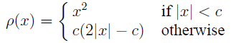
[M.Sc. in Applied Statistics ]

Huber's function is a parabola in the vicinity of zero, and increases linearly at a given level |x| > k .The value k for the Huber estimator is called a tuning constant; smaller values of k produce more resistance to outliers, but at the expense of lower efficiency when the errors are normally distributed. The tuning constant is generally picked to give reasonably high efficiency in the normal case; in particular, k = 1.345 for the Huber produces 95-percent asymptotic efficiency when the errors are normal, and still offer protection against outliers.
Asymptotic efficiency on the standard normal distribution is the ratio of the variance-covariance matrix of a given estimator to that of the least-squares in the presence of Gaussian noise in the data.

Cauchy's function, also known as the Lorentzian function, does not guarantee a unique solution. With a descending first derivative, such a function has a tendency to yield erroneous solutions in a way which cannot be observed. The 95% asymptotic efficiency on the standard normal distribution is obtained with the tuning constant c = 2.3849. The other remaining functions have the same problem as the Cauchy function. As can be seen from the influence function, the influence of large errors only decreases linearly with their size. The Geman-McClure and Welsh functions try to further reduce the effect of large errors. The 95% asymptotic efficiency on the standard normal distribution of the Welsch function, with c = 2.9846.
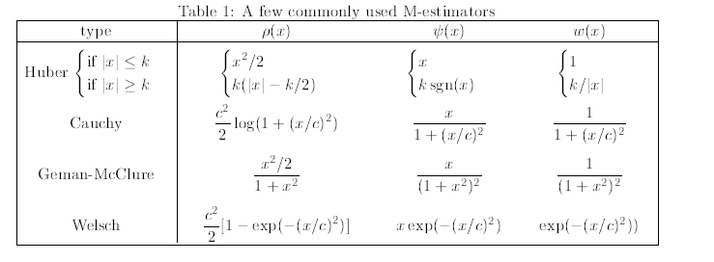
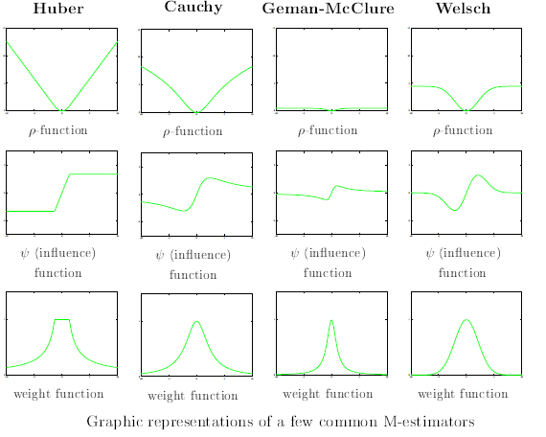
- WRITE ZHANG’s MICROSOFT PAPER for M-ESTIMATORS from page 22-27
The M=Estimator should fulfill the following constraints:
- Influence function should be bounded.
- Robust estimator should be unique; i.e. the objective function should have a unique minimum.
- The influence function ω(x)≠0 when d ω(x)/dx=0

(review work)In an earlier paper proposed in [ ], the Huber’s M-Estimator was used as a cost function for FastICA. The FastICA algorithm so obtained was very simple to implement having very simple to implement. The modified Algorithm had simple multiplication and addition equations. It also performed well and sometimes better than the basic tanh and pow3 as suggested in [ ].
Though it is not proved to be globally stable as per the stability equation in [ ] (which has also not been proved for tanh and pow3), it still satisfies the other requirements of cost function, along with local stability properties. Also, it was proved that Huber was insensitive to its tuning parameter.
- Huber’s Paper from the net

- Please refer the rest of the printout papers for reference and previous work.
Try to make a total of 40-60 page report . Use it for the final paper as well

- FUZZY CLUSTERING WITH POLYNOMIAL FUZZIFIER FUNCTION IN CONNECTION WITH M-ESTIMATORS(For maximum likelihood and M-estimator;Page 2)
- Robust Estimation of a Location Parameter,Peter J. Huber ,Annals of Mathematical Statistics; Volume 35, Number 1 (1964), 73-101.
- Robust Regression,Appendix to An R and S-PLUS Companion to Applied Regression,John Fox,January 2002
- M.Sc. in Applied Statistics MT2004,Robust Statistics,1992–2004 B. D. Ripley
- Image registration using robust M-estimators,K.V. Arya a,*, P. Gupta b, P.K. Kalra c, P. Mitra d,,Pattern Recognition Letters 28 (2007) 1957–1968

